Computer Shop System

Use-Case Specification: View Comment

Version 1.0

Revision History

|  |  |  |  |
| --- | --- | --- | --- |
| **Date** | **Version** | **Description** | **Author** |
| 5/12/2019 | 1.0 | details | Hoang Trung Hieu |
|  |  |  |  |
|  |  |  |  |
|  |  |  |  |

Table of Contents

1. Use-Case Name 3

1.1 Brief Description 3

2. Flow of Events 3

2.1 Basic Flow 3

2.2 Alternative Flows 3

2.2.1 < First Alternative Flow > 3

2.2.2 < Second Alternative Flow > 3

3. Special Requirements 3

3.1 < First Special Requirement > 3

4. Preconditions 3

4.1 < Precondition One > 3

5. Postconditions 3

5.1 < Postcondition One > 3

6. Extension Points 3

6.1 <Name of Extension Point> 3

Use-Case Specification: View Comment

# Use-Case Name

## Brief Description

This use case defines the steps of reviewing computers on the computer shop’s website. Customer can easily review the computers after they have read.

# Flow of Events

## Basic Flow

Customer clicks the image of the computer to go to the detailed information page of that computer. Customer click the comment box to write comments on the computer. If member wants to write comment, member clicks the submit button to submit his comment after having finished with it. Eventually, the system display the comment in the list of the comments of that computer.

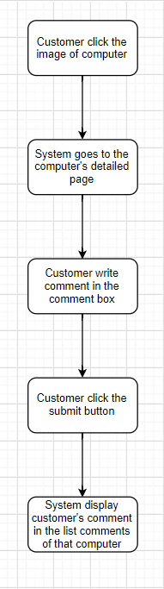

# Special Requirements

The comments which are impolite and inconsistent with Vietnamese habits and customs will not be accepted.

# Preconditions

No preconditions.

# Postconditions

No postconditions.

# Extension Points

No extension points.